* Description of your project
* Pseudo code for algorithms and program flow
* Visual design template or example
* Brief description of how you will test your project

**Description:**

The new interface will include tab-based multiple view controllers, with added view controllers for information about the courses and members of the Atlas Institute. As this app will be an advancement of the previous atlas app, the functionalities of the previous app will be embedded into a tab of the new app.

The app provides the ATLAS institute and programs and courses offered. Also, if the students want to finish the courses faster than 2 year, it will provide the required credentials and mandated courses information. The university provides an online web-based platform to provide the information. The app will facilitate students and staffs to get the brief description about ATLAS institute enrollment.

**Pseudo code:**

* Create app Launcher - Colorado Boulder logo
* Main app storyboard:
  + Create Tab bar controller (three scene)
* First controller –Entering the Atlas Institute credentials/data with username and password
  + - * If a user does not have a username, it can be created. For this, JSON has to be connected to the server. This can be done by locally by downloading MAMP to setup php and mysql. Then using the default settings at [http://127.0.0.1:8888](http://www.google.com/url?q=http%3A%2F%2F127.0.0.1%3A8888&sa=D&sntz=1&usg=AFQjCNHOoNUlJJibABhPEaOCHAJSL9gtTg) and testing it in the browser.
      * Make and add the php files for sign up view controller and run the mysql file with the credentials of required database.
      * Embed this controller in navigational controller.

* Second controller – Regular course description of Atlas
* Third controller – List of members of Atlas Institute with plist in table view.
* Fourth controller – Information about finishing the course before timeline.
  + Connect the buttons to view controller.
  + For portrait and landscape orientation.
* Connect delegate and sources.
* Apply the connections.

**Visual Design template:**

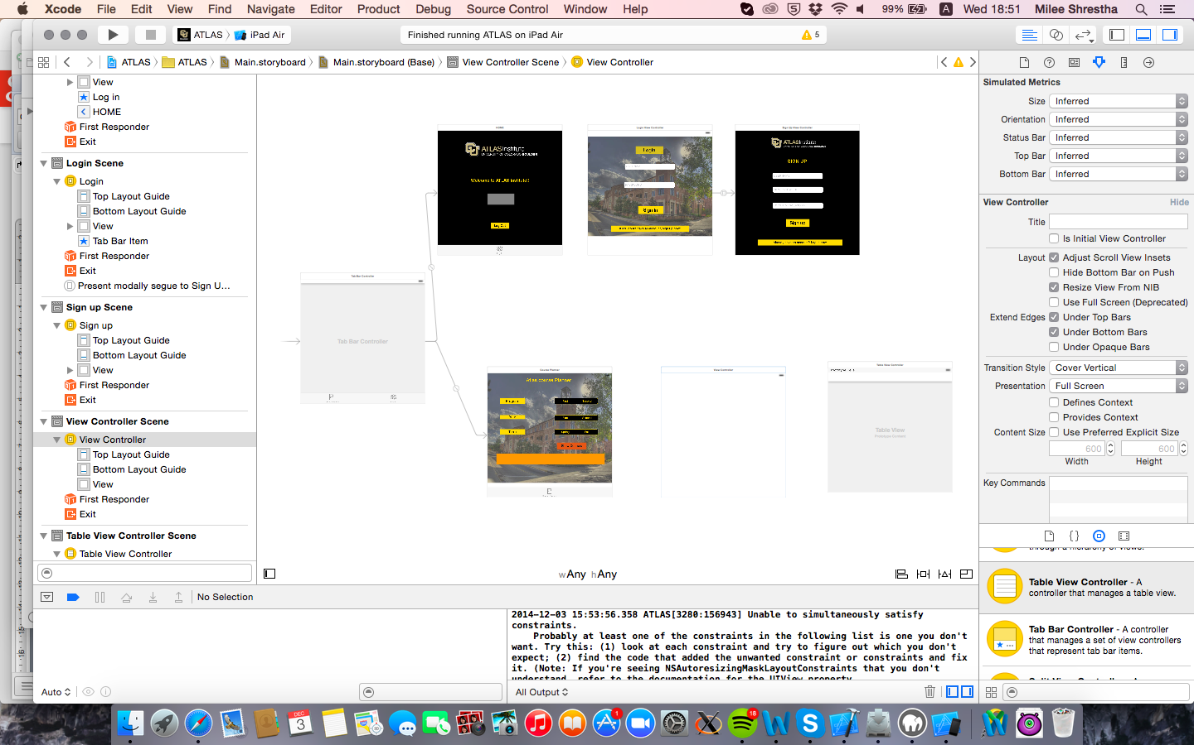

**Testing the Project:**

* Proper Image sizes for app icon.
* Add launchImage.
* Test for proper connection of buttons in connection inspector
* While making new file with Cocoa Touch check the class.
* Check the subclass of view controller.
* Take snapshots after writing every code in controller and make connections.
* Stepwise development (building after every change) so that you know where the error is.
* Debugging by adding breakpoints
* Test the navigational consistency so that information for each condition is displayed correctly.
* Adding and updating of constraints according to the requirement of buttons.
* Check the deployment info and in deployment target always make it 8.0 and above
* Build app in xcode 6.1 and try running it in 6.0.1 to avoid crashes.

**Reference:**

<https://plus.google.com/u/0/+DipinKrishnaMWC/posts/YaycVTYcLdg>

<http://dipinkrishna.com/blog/2013/12/ios-login-screen-tutorial-xcode-5-ios-7-storyboard-json/>